Hunter Sutton

GV Date Project 1

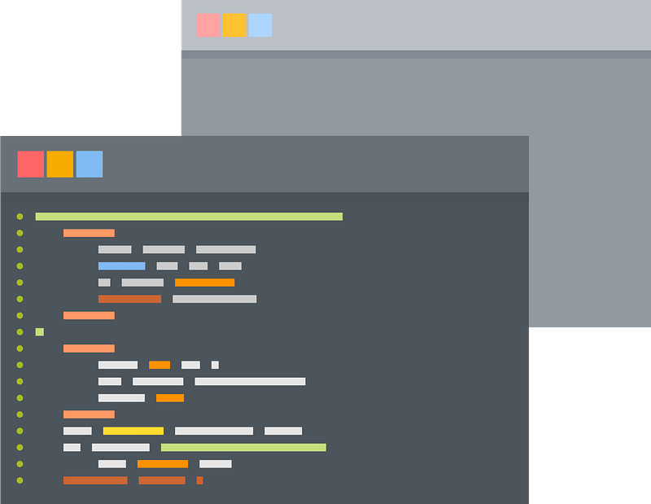

"I pledge that this work is entirely mine, and mine alone (except for any code provided by my instructor). "

I had no help from anyone besides the professor.

Timecard

“I spent 8 hours on this project from September 28th - October 15th reading the zyBooks, writing code, fixing errors and putting together my final document.”

**Sample Output:**

Testing my Birthday

____________________

Is 10/12/2020 my birthday?: false

Testing Leap Year

____________________

Is 2000 a leap year?: true

Testing Date Formats

____________________

Format 1: 10/12/2020

Format 2: 10/12/2020

Format 3: Oct 12, 2020

Format 4: October 12, 2020

Testing Equals

____________________

Is 10/12/2020 equal to 4/15/1976?: false

Is 10/12/2020 equal to 10/12/2020?: true

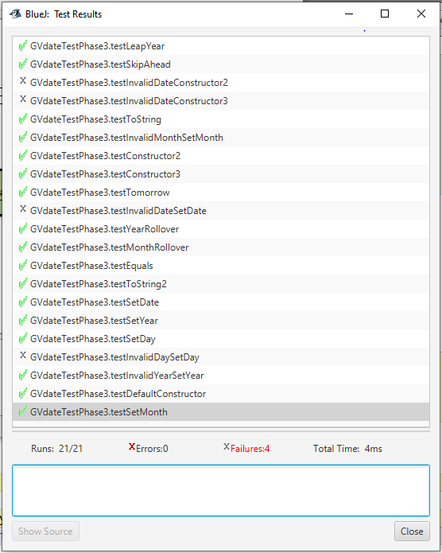**Screenshot of GVdateTestPhase3 showing what I passed.**